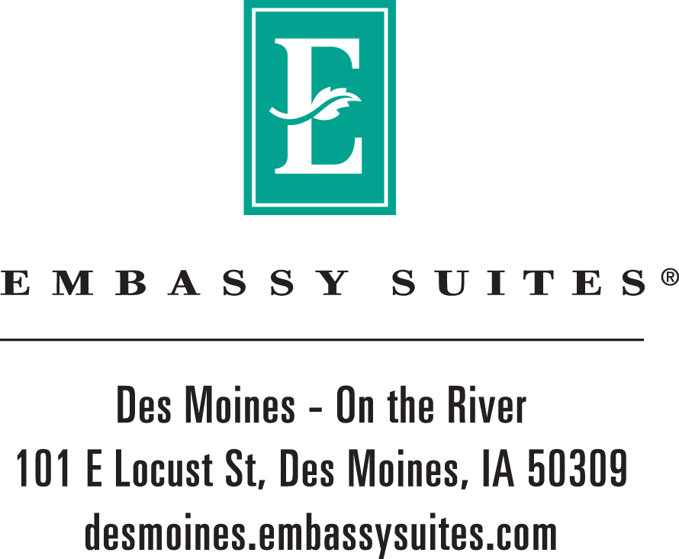

Xenda Lindel
Unitarian Universalist Association.
July 30, 2026

Thank you for the opportunity to submit a proposal for the Unitarian Universalist Association event on April 08, 2011 - April 10, 2011. We sincerely look forward to hosting your group and appreciate the prospect of becoming your preferred “home away from home”!

The Embassy Suites Des Moines- On the River is an award winning John Q. Hammons managed hotel and prides itself in being the only full service all-suite hotel in the state of Iowa. We invite you to discover why Embassy Suites has received the J.D. Powers Award for “Highest Guest Satisfaction Among Upscale Hotel Chains” for the third year in a row!

SUITE FEATURES
- Spacious two-room suite featuring a private bedroom with one king size or two double Serta Perfect Sleeper® beds
- Separate living room with queen size sofa/sleeper, well-lit work and dining area, wet bar, microwave, refrigerator and coffee maker
- Wireless High-Speed Internet Access available
- Two color televisions with cable and pay-per-view movies
- Two telephones with private voice mail that is also accessible from outside phone lines

THE COMFORT AND CONVENIENCE
- Located at the gateway to the Historic East Village which features the city’s newest and trendiest independent dining and shopping destinations
- Situated along the new Principal Riverwalk and just a few blocks from the downtown business district, Iowa Events Center, Court Avenue Entertainment District, Science Center of Iowa and Principal Park- home of the Iowa Cubs.
- Newly renovated indoor swimming pool, and Jacuzzi
- Doozie’s Bar and Grill serving casual American cuisine daily for lunch and dinner
- Secured parking available within our underground parking structure or surface level parking lot for a minimal daily charge

THE VALUE
- Complimentary full cooked-to-order breakfast and nightly Manager’s Reception
- Complimentary 24-hour EmbassyLink™ Business Center
- Complimentary 24-hour newly renovated fitness center featuring leading-edge equipment from Precor®
- Complimentary transportation to and from the airport, as well as within a 2-mile radius of the hotel
- Hilton HHonors® Points & Miles™

SPECIAL CONCESSIONS
- Five ( 5) Complimentary surface lot passes
- Five ( 5) Complimentary underground lot passes
- One (1) Complimentary Guest Room for every 50 used

Guest Suite requirements:

 | Fri  04/08/11 | Sat  04/09/11
Run of House | 175 | 175

Total Number of Rooms: 350

SUITE RATE
Embassy Suites on the River would like to extend Unitarian Universalist Association a $119.00 discounted group rate based upon the specific room requirements stated above. Quoted rates are for single or double occupancy- additional adults in a room would be $10 per person per night. Rates do not include state and local taxes and are quoted on a, per suite, per night basis. All rates quoted are net non-commissionable unless otherwise noted.

CONFERENCE AND BANQUET CENTER REQUIREMENTS

Date | Start Time | End Time | Function | Room | Setup | Agr | Room Rental
4/8/2011 | 8:00 AM | 5:00 PM | Trade Show | Atrium | Tabletop Exhibits | 10 | **$250.00++
4/8/2011 | 5:00 PM | 11:00 PM | Dinner | Salons D-H | Rounds of 10 | 400 | **$3,000.00++
4/9/2011 | 8:00 AM | 5:00 PM | Meeting | Salons D-H | Rounds of 10 | 400 | **$3,000.00++
4/9/2011 | 8:00 AM | 5:00 PM | Breakout | Potomac | Classroom 2 per 6' x18' | 30 | **$450.00++
4/9/2011 | 8:00 AM | 5:00 PM | Breakout | Mississippi/Missouri | Classroom 2 per 6' x18' | 30 | **$450.00++
4/9/2011 | 8:00 AM | 5:00 PM | Breakout | Scott's Landing | Classroom 2 per 6' x18' | 30 | **$450.00++
4/9/2011 | 8:00 AM | 5:00 PM | Breakout | Salon A | Classroom 2 per 6' x18' | 30 | **$450.00++
4/9/2011 | 8:00 AM | 5:00 PM | Breakout | Salon B | Classroom 2 per 6' x18' | 30 | **$450.00++
4/9/2011 | 8:00 AM | 5:00 PM | Breakout | Salon C | Classroom 2 per 6' x18' | 30 | **$450.00++
4/9/2011 | 8:00 AM | 5:00 PM | Trade Show | Atrium | Tabletop Exhibits | 10 | **$250.00++
4/9/2011 | 12:00 PM | 1:00 PM | Lunch | Salons D-H | Rounds of 10 | 400 | $0.00
4/9/2011 | 5:00 PM | 11:00 PM | Dinner | Salons D-H | Rounds of 10 | 400 | $0.00
4/10/2011 | 8:00 AM | 1:00 PM | Meeting | Salons D-H | Rounds of 10 | 400 | **$3,000.00++
4/10/2011 | 8:00 AM | 5:00 PM | Trade Show | Atrium | Tabletop Exhibits | 10 | **$250.00++
**Room rental will be waived with a total minimum food purchase of $28,000.00++. If the food minimum is not met the original room rental will apply.

Our conference center features 16,000 square feet of flexible space, which can be custom designed to meet your specific needs. The conference center is conveniently located within the lobby level of the hotel for easy access from general session rooms to breakout rooms. In addition to our conference center, Our 8 story garden atrium makes the perfect gathering place for luncheon and receptions. Meeting room rental and other conference center pricing quoted do not include applicable tax and gratuity charges.

BANQUET MENUS/ CORPORATE MEETING PLANNER PACKAGEs
Our creative and professional catering department is available to design unique menus to enhance your attendees’ experience at the conference. We have a variety of menu and package options within our new banquet menu. You can view our banquet menu here. (Menu prices subject to change)

I am confident that your group will find the Embassy Suites on the River provides a comfortable, convenient and productive locale. Not only do you get more space when you choose Embassy Suites, you get more value. Comparing apples to apples against our main competitors your group would save approximately $31.45 per day on each room.

I look forward to working with you on this group and hopefully many others in the future. If you have any questions, please contact me at your convenience. This rate proposal is valid for two weeks from July 30, 2026. We are not currently holding space for your group, but would be happy to secure you group immediately with an agreement per your request.

Thank you for your time and consideration.

Sincerely,

Abigail Duncan
Association/SMERF Sales Manager

Please visit our website at http://www.embassysuitesdesmoines.com for additional information.



