2010 PSD CHILDREN and YOUTH PROGRAMMING DRAFT
Roots and Wings: Weaving Multigenerational Dreams A/O 032210

Our Goal in planning this program has been to provide your children or children you sponsor with

an enriching and vibrant multigenerational experience

at the 2010 Prairie Star District (PSD) Conference in Davenport.

Permissions: Please note that anyone younger than 18

must have a signed parental permission form on file in order to participate in the conference.

Decisions – Children’s Activities or Multigenerational Events? Parents and sponsors are responsible for determining whether children will want to participate in the children’s programming listed on this sheet or in the general conference programming. Except when children are specifically in the care of conference staff, parents will be responsible for their whereabouts and activities. Where to check children in? At the purple balloon bouquet!
Staff Qualifications and Background Checks – To ensure the safety and well-being of participants, all volunteers working directly with children have had prior experience working with young people and have had a background check, completed by the Director of Religious Education of the Unitarian Church, Davenport.
Questions or Concerns?  Contact Sarah Moulton, Religious Education Director of the Unitarian Church, Davenport, at any time during the conference with questions or concerns.  Her number is: 563-940-5693  If you cannot contact Sarah, call Barb Robinson at 1-810-333-3812 |  |  |  | Which Group Fits My Child’s Age?  - Infants and Toddlers and preschoolers too young for group or cooperative activities may be cared for in our Child Care rooms in the Radisson: Rooms 205 and 206 on the second floor of the hotel, above the lobby. Childcare is available on Saturday from 8:00 am – 12:30 pm and 2:00 – 5:00 pm and for choir members, on Sunday from 8:00 am – 9:00 am. At other times, children of this age range will participate with their parents in general conference activities.  - Children (as distinguished from Infants and Toddlers and from Youth) include preschoolers who are able to participate actively in group activities and elementary aged children through Grade 6.  - Youth (teens or Grades 7 – 12) will participate in programming, described separately just below, tailored more to their interests.
Hang Out in the Random Room  Where random acts are bound to happen . . . Random Acts of Art (RAA), Random Acts of Kindness (RAK), Random Acts of Thought (RAT) and Random Acts of Music (RAM) – and lots of other Random Acts as well.  We’ll use cameras, camcorders, cell phones, CDs and other tools – for fun and to create a random act of experience and sharing. Scrapbooks, journaling, collages, superhero comics, artists’ trading cards – we’ll brainstorm and then we’ll do! It’s all up to you in the Random Room.  Thank you, children and youth of all ages,  for joining us in Davenport! |  |  |  |  | 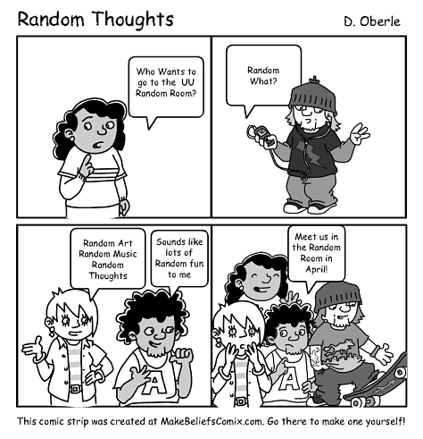

FRIDAY, APRIL 23
4:00 – 6:00 |  | All-conference, all ages | Pre-Conference Mexican Dinner and Open Mic Entertainment |  |  |  | River Music Experience (reservation required).
7:00 – 8:30 |  | All conference, all ages | Multigenerational Opening: Banner Parade, Welcoming Celebration, LREDA Kick-Off Presentation & Worship |  |  |  | Radisson Quad City Ballroom
8:30 – 10:00 |  | Children grades 1 – 6 only | Popcorn and Movie Party |  |  |  | Parents take children to Radisson Rooms 205 – 206
8:30 – 11:00 |  | Youth | Random Room – What will the Random Room be? Come see . |  |  |  | Radisson Board Room

SATURDAY (April 24)
7:00 – 12:15 | All ages except Infant &Toddler |  | See general conference schedule. With two exceptions, participants of all ages will take part in breakfast, and the combined Arthur A. Judy Lecture and Workshop A:  - Childcare for Infants and Toddlers from 8:00 – 12:30 (again from 2:00 – 5:00).  - Quiet activities for Children and Youth during Business Meeting from 8:00 – 9:00 |  |  | Parents and sponsors responsible for all Children and Youth throughout the morning, with the following exceptions  - Childcare for Infants and Toddlers from 8:00 – 12:30 in Radisson 205 & 206.  - Quiet activities in the Mississippi Hall at the side
8:00 am – 10:00 pm | All ages |  | Exhibits and Bookstore open – Also Make-It Take/It Activities (8:00 – noon; 1:30 – 6:00) |  |  | All in RiverCenter South – Lower Concourse
12:30 – 1:30 | Children  Youth  Adults & Infants and Toddlers |  | Offsite Scavenger Hunt and Picnic  Random Room  Awards Luncheon |  |  | Field trip to LeClaire Park – along Mississippi. Meet at the purple balloons, outside the Mississippi Hall after Dr. Hicks’ presentation  RiverCenter South – Great River Hall (RR will be in back of room, behind curtains! Find it!  River Center South – Great River Hall
2:00 – 3:15 | Children  Youth |  | Choice: Either attend:  Workshop B8: John McCutcheon (with supervised Children’s group  or Workshops B1-B7 (with parents supervision) |  |  | B8 - RiverCenter North – Mississippi Hall. Meet at the purple balloons outside the hall  B1-B7 see Conference Schedule
3:30 – 4:45 | Children  Youth (both attend both) |  | Laughter Yoga  Make Some Noise (Percussion!) |  |  | Both groups meet in RiverCenter South – Great River all. Children at purple balloons, youth in Random Room
5:30 – 6:45 | All conference, all ages |  | Informal Family Dinner |  |  | RiverCenter South – Great River Hall
7:00 – 8:30 | All conference, all ages |  | Concert: An Evening With John McCutcheon |  |  | RiverCenter North – Mississippi Hall
8:30 – 10:00 | Children grades  1 – 6 only |  | Popcorn & Movie |  |  | Children meet in Radisson Rooms 205 – 206 RiverCenter South
8:30 – 11:00 | Youth |  | Random Room |  |  | Youth meet in Random Room in Great Hall
SUNDAY (APRIL 25) – Except for Child Care During Choir Rehearsal, families will take part in all activities together.
Child Care during Choir Rehearsal (8:00 – 9:00 a.m.) in Rooms 205 and 206, Radisson

