Unitarian Universalist Congregation of Duluth
Reverend Gail Marriner, Interim Minister
ministeruucd@gmail.com (218) 724-6084

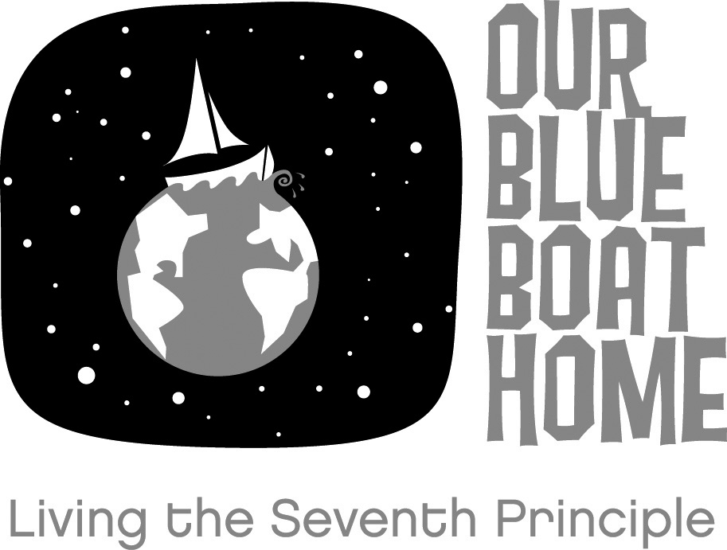
The Unitarian Universalist Congregation of Duluth, Minnesota (UUCD) is excited to be host congregation for the 2009 Annual Conference of Prairie Star District of the Unitarian Universalist Association April 3-5, 2009. We at UUCD are equally excited about the theme of the conference: “Our Blue Boat Home: Living the Seventh Tradition.” Folksinger/songwriter Peter Mayer has given us permission to use his song title for our theme, and he will be delivering the annual Arthur M. Judy Lecture at the Conference. We want to extend a warm invitation to our friends in the district to travel to Duluth April 3-5, 2009 to attend the conference.

There’s a lot more to learn about the program at the 2009 PSD Conference, and your most comprehensive source is the district’s Web site at www.psduua.org/AnnualConference2009. That’s also where you will register—all registration is on line—in early 2009. Our goal in this letter is to shamelessly promote our city and congregation as hosts for the conference.
- No, we can’t promise extra-balmy weather in early April in Duluth. There might even be a few lonely chunks of ice floating in the harbor. But this is Duluth! Gaze out at the Big Lake, take a walk on the Lakewalk, tour the Maritime Visitor Center (the second most visited attraction in Minnesota!), or just revel in the past and future of the entrance point to Minnesota’s North Shore.
- Tour our new congregational home. Worshipping in our new building would be worth the trip alone (We’re not suggesting that, of course. Come for the conference.). We were the first congregation in Minnesota to be named a Green Sanctuary by the Unitarian Universalist Ministry for Earth, and our new building—from its green roof to its indoor garden to the materials used in construction—embodies, we believe, our seventh tradition. You’ll see for yourself when you worship with us April 5.
- The venue for the conference, the Duluth Holiday Inn, will be a great gathering place for the conference. Extremely reasonable room rates. Totally wireless access. And a terrific, huge ballroom that will serve as our central gathering space.

It’s not too soon to save the weekend of April 3-5, 2009 for the first-ever Prairie Star District Annual Conference in Duluth. Please share this poster and invitation with everyone in your congregation or fellowship. The PSD Web site also has the “Blue Boat Home” poster in two sizes for you to print and post, and a wealth of additional information about the conference. We hope to see you in Duluth!

835 West College Street Duluth, MN 55811
Kathy Stinnett, Congregational Administrator
Office phone: 218-724-0308 uucduluth@gmail.com http://www.uuduluth.org

