Prairie Star District Annual Conference
April 13 – 15, 2007

Nurturing our Faith Communities

Keynote: Try a Little Tenderness

What can we do to create congregations with resilience, vitality and agility as we respond to the challenges of our time? Our keynote speaker, Laurel Hallman, will give us a new lens with which to view our faith communities.

Laurel Hallman has been the Senior Minister of the First Unitarian Church of Dallas for 20 years. She found Unitarian Universalism in St. Paul, Minnesota at Unity Church – Unitarian in 1965, was called into the ministry from that church, and was ordained there 26 years ago. She says, “It will be good to be home in the Prairie Star District again.”

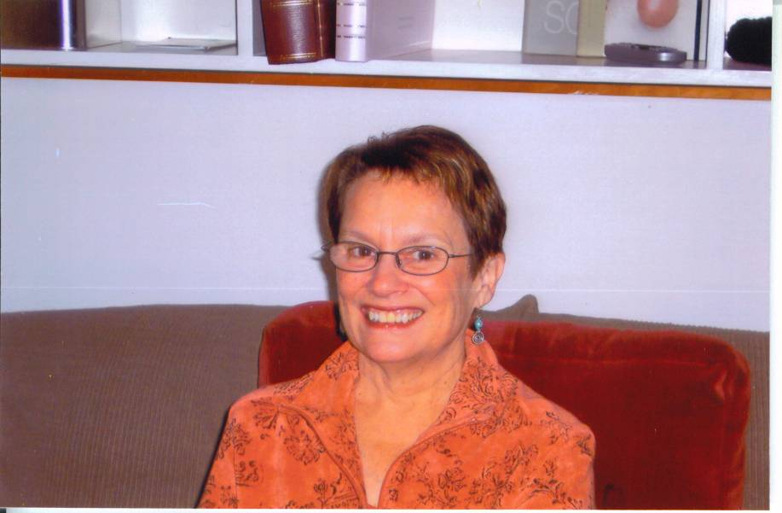

Workshop: When She Gets Weary

The workshop time will be devoted to planning specific (and sometimes subversive) ways to nourish your congregation’s spirit.

