
REMIND YOUR CONGREGATION TODAY
of the 2007 Prairie Star District Annual Conference
Co-hosted by First Unitarian Society of Minneapolis
and the Annual Conference Program Working Group

Nurturing Our Faith Communities

April 13-15, 2007, City Center Marriott, Minneapolis

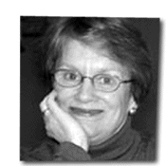
Keynote Speaker: Rev. Dr. Laurel E. Hallman, Senior Minister of the First Unitarian Church of Dallas and author of Living by Heart: A Guide to Devotional Practice. She has been instrumental in establishing the UUA's first ‘fast start’ congregation in Keller, Texas.

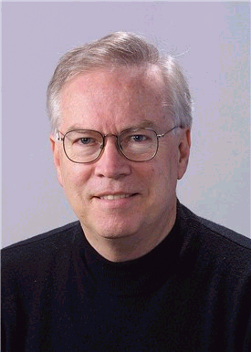
Judy Lecturer: Bill Doherty, professor, University of Minnesota department of family social science. Mr. Doherty holds degrees in philosophy, theology, child development and family relations, and family studies. His interests include democratic community building with families. His writings include Take Back Your Marriage: Sticking Together in a World that Pulls Us Apart and Take Back Your Kids: Confident Parenting in Turbulent Times.

Join UUs from across eight states!
This year we’re paying special attention to integrating the youth of the district into the annual conference. UUA staff members will be there to meet with youth and adults as part of its “Consultation Ministry to and with Youth.”

You’ll also find timely, practical, and fun activities, including multigenerational workshops on nurturing our faith communities. (If you or someone you know has a workshop to suggest, feel free to copy the attached application as needed, fill it out and return it by October 10.)

In Minneapolis, you will also find:

- an integrated youth program, child care
- celebration, worship, reverence, remembrance
- handshakes, hugs, social time, choir singing
- music, food, fun, laughs
- a banquet, awards, entertainment
- books, exhibits, gifts
- the annual business meeting

Everyone loves the banner parade. Be a part of it!
Go to www.uua.org/ga/banners.html for easy instructions on creating and displaying your congregation’s banner. Then bring it to Minneapolis!
Watch for registration materials in mid-winter. Early registration discounts will apply.
For more information, contact Eric Severson at 608-785-1274 or at uuseverson@prodigy.net.

This announcement is going out this year electronically only. You will not receive it in the mail. Please forward it to anyone else who might want to know! Feel free to copy this flyer for your congregation’s website, newsletter or bulletin board.

Deadline to apply: October 10, 2006

Prairie Star District Annual Conference
APPLICATION FOR WORKSHOP PRESENTATION
April 13 - 15, 2007
Co-hosted by First Unitarian Society of Minneapolis
Theme: “Nurturing Our Faith Communities”

NAME of principal presenter:
If youth, name of adult sponsor:
Home congregation:
Past workshop/speaking experience:
Your address:
City: State: ZIP:
Home phone: Work phone:
Email address (required):
NAME of copresenter:
If youth, name of adult sponsor:
Home congregation:
Past workshop/speaking experience:
Your address:
City: State: ZIP:
Home phone: Work phone:
Email address (required):

Workshop title (as brief as possible, please):

Abstract (Please write description as you would like it to appear in the conference brochure):

Is this workshop intentionally multigenerational? Yes No
Into which of these focus areas does this workshop primarily fit? (Please pick one.)

Art
Communication
Community
Family
Growth
History
Justice
Leadership
Ministry
Music
Religious Education
Resources
Spirituality
Theology
Tour
Worship
Other:

What can participants expect to take away from this workshop?

Are there any titles related to your workshop that you would recommend for the conference bookstore?

Do you need special equipment or space set up? (We’ll try to provide it; if you don’t list it here, it can’t be guaranteed.)

Return application to: (Deadline: October 10, 2006)
Save this document, then attach it to an email (uuseverson@prodigy.net), or print and send it by regular mail to:
Eric Severson, PSD Workshops
1316 Market Street, La Crosse, WI 54601

Please Note: Upon confirmation of workshop acceptance, all workshop presenters are expected to register and pay appropriate conference fee. Thank you!

