
Nurturing
Our
Faith
Communities
Prairie Star District Annual Conference
April 13-15, 2007
Minneapolis Marriott City Center
Minneapolis, MN 55402

Our congregations are places of nurture for our souls, our families, our communities and our world.
Come and join with other Unitarian Universalists to learn how to strengthen our fellowship and deepen our values in this ministry we share.

Hosted by the PSD Annual Conference Planning Committee
and the First Unitarian Society of Minneapolis

Schedule |  | General Session Highlights
Friday, April 13  Registration 4:00-7:00 PM  UU Bookstore  and exhibits open 6:00-7:00 PM  Opening celebration  and banner parade 7:00-7:45 PM  Keynote address 7:45-8:45 PM  Keynote discussion 8:45-9:15 PM  Worship service 9:30-10:00 PM  Saturday, April 14  Breakfast, and table  topics 7:30 – 9:00 AM  UU Bookstore  and exhibits open 8 AM to 7 PM  Judy Lecture 9:00 - 10:15 AM  Workshop A 10:30 - 11:45 AM  Awards luncheon 12:00 - 1:15 PM  Workshop B 1:30 - 2:45 PM  Refreshments 2:45 - 3:15 PM  Workshop C 3:15 - 4:30 PM  Business meeting 4:45 - 6:15 PM  Social hour, cash bar 6:15 - 7:00 PM  Banquet & Dance 7:00 - 9:00 PM  Youth-led worship service 9:15 PM  Sunday, April 15  Breakfast, and table  topics 8:30- 10:00 AM  Worship service at  the First Unitarian Society 10:30 AM |  | Keynote - Friday, 7:45 PM  Try A Little Tenderness  Rev. Dr. Laurel E. Hallman  Senior Minister, First Unitarian Church of Dallas, Texas  What can we do to create congregations with resilience, vitality and agility as we respond to the challenges of our time? Our keynote speaker, Laurel Hallman, will give us a new lens with which to view our faith communities.  Laurel Hallman has been the Senior Minister of the First Unitarian Church of Dallas for 20 years. She found Unitarian Universalism in St. Paul, Minnesota, at Unity Church–Unitarian in 1965, was called into the ministry from that church, and was ordained there 26 years ago. She says, “It will be good to be home in the Prairie Star District again.”  The Arthur M. Judy Memorial Lecture - Saturday, 9:00 AM  Home Grown Religion  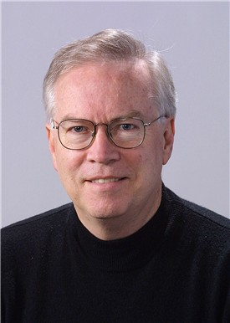  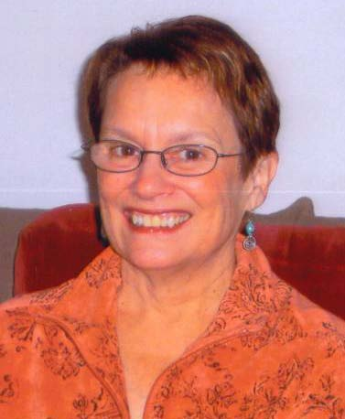  Dr. Bill Doherty  Professor, University of Minnesota Department of Family Social Science  Religion is taught, or caught, mostly in the family. How can our faith tradition go more deeply into our homes? How do we create a gravitational pull around Unitarian Universalism so that more of our children feel drawn back when they grow up and form their own families? The answer won't come in the form of traditional programming. We need a fresh approach.  Bill Doherty holds degrees in philosophy, theology, child development and family relations, and family studies. His interests include democratic community building with families. His writings include Take Back Your Marriage: Sticking Together in a World that Pulls Us Apart and Take Back Your Kids: Confident Parenting in Turbulent Times. He is a member of First Universalist Church, Minneapolis.  “Wild Rhubarb” Saturday Evening Banquet  "Wild Rhubarb" is a cooperative band supported by the Twin Cities Urban Folk School. Members volunteer their time and any proceeds earned go to support folk school operations. Dave Leussler leads the band and calls traditional dances for all ages and abilities. Attending a "Wild Rhubarb" dance is a chance to build community with your fellow participants supported by passionate music and buoyed by powerful traditions. "Wild Rhubarb" is always open to drop in musicians from the group. No experience necessary!
  Sunday Breakfast and Worship will be held at the First Unitarian Society of Minneapolis, located downtown just steps from the Walker Art Museum. Shuttle transportation will be available at the hotel beginning at 8:15 a.m. Parking is also available for $1.00 in the Walker Center Parking Ramp. Directions will be given in your registration packets.

General Information
ACCOMMODATIONS  Minneapolis Marriott City Center  30 South Seventh Street  Minneapolis, MN 55402  The Marriott City Center is located in the heart of our downtown’s entertainment district, just a block away from the city’s new light rail service to such destinations as Minnehaha Falls Park, the Mall of America and the airport.  Hotel Reservations  A discounted rate of $99 per night per room for one to four occupants is available. Children under age 18 may stay free with a parent. Rooms must be reserved by March 16, 2007.  For the discounted rate, please specify that you are attending the Unitarian Universalist Prairie Star District Conference.  Phone: 1-800-228-9290  Fax: 612-332-7165  Web: www.Minneapolismarriott.com  PARKING  Parking is available at reasonable cost for conference participants in the parking ramp adjacent to the hotel.  Many thanks to Kevin Robertson, who designed our logo! | REGISTRATION  Registration is $135 for adults. Please photocopy the registration form for each attendee 12 years old and older. Early bird registration ($120) for adults must be postmarked by March 16, 2007.  To register online, visit www.psduua.org/AnnualConference . Full refunds available until April 1.  Youth Program  Registration for youth is $50. All attending youth must be sponsored by an adult who is attending the conference. Let your congregation know if you are willing to be a sponsor. Youth will participate in the full Annual Conference and are encouraged to attend the special consultation with the UUA. Youth will provide the Saturday evening worship service. For more information, see the enclosed “Youth Conference” registration form.  MEALS  Adult registration includes Saturday breakfast, lunch, and dinner at the hotel and Sunday breakfast at First Unitarian Society. If you prefer vegetarian meals, or have other dietary needs, please indicate this in advance on your registration form.  Questions?  For more information, contact Rev. Lisa Friedman, lfriedman@gfn.org  612-781-5182. | Banner Parade  The Banner Parade will be Friday evening, and banners will be exhibited throughout the conference. You are invited and encouraged to bring your congregation’s banner (and pole) for the parade. To learn more about creating a banner, visit www.uua.org/ga/bannerspecs.pdf .  Child Care  Child care will be available at the hotel for children ages 3-11 years. The fee is $40 per child; registration must be received by April 1, 2007.  Sunday MORNING  First Unitarian Society welcomes you to experience the combined choirs of First Unitarian and First Universalist Church and our orchestra performing "Sources", a dynamic musical presentation based on the six sources of our UUA Purposes and Principles. Composed by Jason Shelton, Music Director at the UU Church of Nashville, with lyrics by Kendyl Gibbons, Senior Minister of the First Unitarian Society, this Cantata will have you singing, shouting, and making a joyful noise about the inspiring faith we share.  Choir  The Annual Conference choir is on sabbatical this year, due to the special musical presentation.
Help us to nurture justice in the wider community by focusing UU generosity on
the American Refugee Committee’s efforts in Darfur
The American Refugee Committee is a Minneapolis-based international nonprofit, nonsectarian organization that has provided humanitarian assistance and training to millions of beneficiaries over the last 27 years. ARC works with refugee communities in 10 countries around the world, helping people regain control of their lives. The people ARC serves have lost everything to events completely beyond their control. ARC provides shelter, clean water and sanitation, health care, skills training, microcredit education, protection and whatever support they can give to let people begin again. Our Sunday morning collection will be for ARC's efforts in Darfur. Currently in Darfur, ARC runs 16 Primary Health Clinics, repairs or builds one wateryard and one new well per month, provides books, classrooms, school kits, and water systems to 8,000 school-age kids, and assists farmers with seeds, tools, training, care of livestock, and development of community gardens. For more information, please visit www.arcrelief.org

SESSION A Workshops
10:30 to 11:45 AM, Saturday, April 14
A1 - Faith Without Certainty: UU Theology  Kathryn Bowman, Unitarian Church Davenport, IA  Come explore the contents of Paul Rasor's new book in UU theology, Faith Without Certainty. After a discussion based on the book’s introduction, participants will receive a leader's guide to facilitating a book discussion in an adult religious education class and suggestions for use of this guide in their own congregations.  A2 - Drumming the Soul Awake  Jaime Meyer and Chris Bremer, First Universalist Church Minneapolis, MN  Through 15% lecture and 85% experiential learning, we will offer powerful insight into the ancient traditions of drumming as a spiritual practice, a way of earth-centered worship, and healing using the community as a container. Drawing from Celtic and northern European shamanic traditions, discover how to introduce drumming into your congregation at various levels, from simple to complex. The copresenters have led monthly drumming groups at their congregation for five years. Drums and rattles are provided.  A3 - Welcoming Congregations, Praise and Challenges  Carolyn Macdonald and Rev. Michael Nelson, Unitarian Universalist Fellowships of Lawrence and Manhattan, KS  Come assess the Welcoming Congregation movement in our District, honor congregations that have achieved official Welcoming Congregation status, offer tips for success to those in the process, and discuss ways to keep the program vital and refreshed as we move forward.  A4 - Making the District Web Site Work for You  Ben Stallings, Prairie Star District Web Coordinator  The PSD Web site has become much more dynamic and interactive, but until now only District staff and a few volunteers have been in the driver’s seat. Come learn how in just minutes you can update your congregation’s listing in the PSD Directory or post the latest news from your PSD committee.  A5 - Nurturing Social Justice in PSD Congregations  Tom Lo Guidice, Vicki Pratt, Caron Wells, Bob Ciernia, Betsy Allis, and Jo Haberman, PSD Social Justice Network  Social justice has moved from “heroes and sheroes" to a systematic approach to change. We will report on alliances, clusters, CBCOs, steering committees, and national efforts that organize our PSD congregations for social action. | A6 - Valuing Our Church Staff and Ministers  Louise Livesay, Unity Church-Unitarian St. Paul, MN  Is your church considering hiring a new employee or minister? Are you looking for a position in a congregation? Wondering how the church can retain good employees? Come speak with the PSD Compensation Consultant about issues relating to compensation and benefits for your church staff and minister. Discuss how we can put our UU values into action as an employer. Learn what benefits are available through the UUA for your church staff.  A7 - Paths Toward Racial and Cultural Inclusiveness  Sharon Blevins, Connie Brown, Art Collins, Jim Eller, Bob Miller and Linda Vogel, All Souls Unitarian Universalist Church Kansas City, MO  We all want diversity, but how can we invite and involve people different from ourselves? What makes the difference between real inclusiveness and window-dressing? Come participate in a sampling of the efforts to walk the talk at All Souls and learn about a range of programming and activities designed to lead the congregation toward becoming a mosaic of many colors.  A8 - Try A Little Tenderness, Part 2  Rev. Dr. Laurel Hallman, First Unitarian Church Dallas, TX  Continue the conversation from our keynote address on how we can create resilient, vital, and flexible congregations to meet the needs and challenges of today.  A9 - The Family Chalice Project  Dr. Bill Doherty, First Universalist Church Minneapolis, MN  Learn about two innovative ways to go deeper into our faith tradition: Spiritual Pressure Point groups for parents and other adults, and a family meal ritual that tells the creation stories of Unitarian Universalism and pulls us into the questions these stories pose today.  A10 – What’s the Buzz on Youth Ministry? Part 1  Tom Rylett and Tandi Rogers Koerger, UUA Task Force on Youth Ministry  Join PSD youth and adults to discuss what Prairie Star is doing well and could share with the rest of the UUA, explore additional opportunities for youth, envision a vibrant PSD youth ministry, identify resources needed, and commit to action and follow-through. Plan to attend all three workshops on this topic to take full advantage of this chance to shape our future youth ministry.

Session B Workshops
1:30 to 2:45 PM, Saturday, April 14
B1 - Through the Windows of Our Souls: Images of UU Faith  Rev. Laurie Bushbaum, UU Minister  Come join artist/minister Rev. Laurie Bushbaum to create a piece of community artwork that will be available to UU congregations in the district. Anyone can participate!  B2 - Where Does Christianity Fit?  Mary R. Sawyer, Unitarian Universalist Fellowship of Ames, IA  We all reject fundamentalist Christianity, but what about liberal/ progressive/ feminist/ liberationist expressions of Christianity? Explore what resources Unitarian Universalists can draw from Christianity to enhance our spirituality and to help live our principles. As we seek more inclusive communities, let us not exclude those who still have an affinity for the teachings of Jesus.  B3 - Nurturing Your Professional Religious Educator Means Nurturing Your Community!  Benette Sherman and Other LREDA Officers.  Liberal Religious Educators Association members will present on nurturing your professional religious educator (DREs, youth directors, volunteers) so they can continue to nurture your faith community. We will speak about covenanting, the credentialing program, professional development, Good Officers and more. If your congregation wants a high-quality and meaningful lifespan faith formation program, then providing support, encouragement and nurturance of your religious educator is necessary.  B4 - Connecting Congregations Through Resource Sharing  Dawn Cooley, Unitarian Universalist Fellowship of Ames, IA  Stonetree Congregational Resources is a practical application of the best inter-congregational communication: You refer people who have benefited your congregation through speaking, music, or other skills such as conflict management, so their skills can be shared with other UU congregations, and you find resources from other UUs that benefit your own. Learn to use Stonetree’s new version to gain the most benefits for minimal effort!  B5 - Prairie Star District: Here to Serve You  Nancy Heege, District Executive; Kathy Bowman and Libby Starling, District Board members  If you have a gripe, a wish, or an accolade, we'd like to hear from YOU! The District is evaluating the services we offer to ensure alignment with congregations' needs. Please join us for a lively discussion of current and future needed services. | B6 - What’s the Score with SCORE?  Graham Kreicker and Rev. Lisa Schwartz, Unitarian Universalist Fellowships of Lawrence and Topeka, KS  Come and hear about the continuing operation of the Southern Cluster Outreach & Extension (SCORE) lay/clergy partnership for growth and view a preview of plans for the coming year.  B7 - Films, Faith, and Fellowship  Carolyn MacDonald, All Souls Unitarian Universalist Church, Kansas City, MO  Explore ideas about starting and running a film series, drawing from the positive experiences with a weekly documentary film series at All Souls UU Church in Kansas City. We will discuss the selection of films, including sources, screening rights and fees; the connection to social justice work; and opportunities for outreach to other community individuals and groups.  B8 - Protecting Voting Rights (the Cornerstone of UU and American Democratic Principles)  Jennifer Thomas and Carol Johnson, First Universalist Church of Minneapolis, MN  With the integrity of our elections seriously eroding, most Americans do not trust their outcome. In 2006, at least 80% of our votes will be tabulated by machines with documented security vulnerabilities. Protecting our access to voting and our voting process, so we can have confidence that the results reflect the people’s will, is the first step to achieve before we can realize gains on any progressive issues from the environment, to peace, reproductive rights, or civil liberties. Generations of women and people of color fought too long and hard to earn the right to vote; it is our duty to protect it. UUs must be leaders on this critical issue.  B9 - Developing and Integrating a Parish Nursing Program  Workshop Cancelled.  B10 - What’s the Buzz on Youth Ministry? Part 2  Tom Rylett and Tandi Rogers Koerger, UUA Task Force on Youth Ministry  This workshop continues the conversation begun in workshop A10.

Session C Workshops
3:15 to 4:30 PM, Saturday, April 14
C1 - Treasures in Our Pockets: The How and Why of Intergenerational Worship  Rev. Laurie Bushbaum, UU Minister  Church is one of the last places in our culture where we can regularly be a multigenerational community. Worship nurtures souls. So how can we be all together in worship? Come practice.  C2 - We're Gonna Have to Sing Our Way Through This!  Rev. Don Rollins, Nora Unitarian Universalist Church, Hanska, MN  Sometimes it appears as though UUs resist truly singable music. This is a chance to learn and sing some songs that can lift our hearts and feed our souls.  C3 -Being Religious in School  David Schwartz, UU Ministerial Candidate  In the public school classroom, how do we live out our values as UU students, teachers and ministers? Can public secondary education be UU ministry? Explore how to live our religious values in the public school, the specific challenges and unique opportunities of this work, and our own stories of finding sustenance through our religious community for life in education as a student or educator. As a student, secondary school teacher, religious education teacher, or minister, what is your story of the intersection of your religious values and education?  C4 - Inspired Faith, Effective Action  Adam Gerhardstein, UUA Washington Office for Advocacy  Learn how UUs can do social justice work effectively and strategically to influence culture and policy, in a way that is grounded in our religious values, accountable to the community and rewarding for all involved. We will cover our theological foundation for social justice, accountability, building relationships, strategic planning, effective advocacy and celebrating our accomplishments.  C5 - Faith and Action: Discussing Reproductive Choice  Pamela Vincent and Kelli Clement, First Universalist Church of Minneapolis, MN  This workshop introduces the pilot curriculum developed by the Religious Coalition for Reproductive Choice. Developed specifically for Unitarian Universalists, it provides a four-part curriculum designed to bring more light and less heat to a potentially divisive topic. Trained to teach this curriculum, the presenters have taught it at First Universalist in Minneapolis. | C6 - You Can Say That Again – Finding Peace Through the Use of a Mantra  Lori Allen and Cheryll Wallace, Unitarian Church Lincoln, NE and First Unitarian Church of Omaha  This workshop is an introduction to the mantra, simple repetitive words, used for centuries to bring peace and balance in the midst of chaos or calm. Along with an introduction to time-honored mantras, participants will create a symbol that is a reminder of these sacred words. Prairie Star Religious Educators Lori Allen and Cheryll Wallace will facilitate.  C7 - The Great Turning  Betsy Allis, First Universalist Church of Minneapolis, MN  Come view David Korten’s widely acclaimed presentation on The Great Turning: From Empire to Earth Community, delivered at the 2006 UUA General Assembly. Discuss his comprehensive plan for changing the direction of society away from the dominator model that has prevailed for 5,000 years toward a more sustainable Earth Community. Learn how UUs can play a powerful role in this shift. Led in partnership with UUs For a Just Economic Community (UUJEC) and UU EcoMinds, a working group of the MN UU Social Justice Alliance.  C8 - Bringing Our History to Life  Lowell Hanson and Jerry Lakso, White Bear Unitarian Universalist Church, Mahtomedi, MN  Join us for a first showing of two new PSD Heritage Committee history DVDs, a preview of two fall 2007 one-day video production workshops, and identifying important history stories to be dramatized. Jerry Lakso and Steve Goranson, both professional video producers, will present.  C9 – After Disaster  Rev. Jim VanderWeele, Community Church Unitarian Universalist, New Orleans, LA  A retrospective. How might a church address pastoral concerns and planning issues after a disaster? The topics include maintaining contact, post traumatic stress, loss of members, building a reconstruction plan, and the formation of a cluster: The Greater New Orleans Unitarian Universalists (GNOUU).  C10 - What’s the Buzz on Youth Ministry? Part 3  Tom Rylett and Tandi Rogers Koerger, UUA Task Force  This workshop continues the conversation begun in workshops A10 and B10.

PSD Annual Conference Registration Form
- Register
by mail to First Unitarian Society, 900 Mt. Curve Ave, Minneapolis, MN 55403
or
online at www.psduua.org/AnnualConference .
- Please copy the registration form for each attendee 12 and older.
- Adults who register by March 16, 2007, will receive an early registration discount.
- Adult registration includes Saturday breakfast, lunch, and dinner and Sunday breakfast.
- For each youth registrant (age 12-18), please attach enclosed youth registration form,
and include the name of the adult sponsor who will be attending the conference.
- Register children 11 and younger on an adult’s form.
Registrant
Name (as it will appear on badge): ____________________________________________________________________
Address: _________________________________________________________________________________________
Street Apt City State ZIP
Evening phone: ______________________________________ Email: _______________________________________
Name of congregation: _____________________________________ City, State: _______________________________
□ Yes, my contact information may be shared with other participants as part of a conference participants’ roster.
Workshop Registration - Please indicate Saturday workshop preferences by workshop number, below:
SESSION A, 10:30-11:45 AM  First choice: #A ________  Second choice: #A ________ | SESSION B, 1:30 to 2:45 PM  First choice: #B ________  Second choice: #B ________ |  | SESSION C, 3:15 to 4:30 PM  First choice: #C ________  Second choice: #C ________
Child registration  Your registration must be postmarked no later than April 1, 2007, to be eligible for childcare. Childcare with age-appropriate activities for children younger than twelve will be provided for a fee of $40 per child. Care will be available Saturday, 8:45 AM-Noon and 1:30-6:00 PM. Fee includes Saturday lunch, dinner, and snacks.  Child’s name: ____________________ Age: ________  Child’s name: _______________________ Age: _________  Table topics  At breakfast on Saturday and Sunday, you’ll have opportunities to talk with others interested in a common topic. If you have an idea for a table topic, please note it here:  _______________________________________________  Are you willing to lead the discussion? □Yes □ No  Special needs: I would like:  - Home Hospitality lodging  - To have my name on the “want a roommate” list and to be sent a copy  - To have my name on the “want to carpool” list and to be sent a copy  - Vegetarian meals  - Other special assistance to participate in the conference or dietary needs (describe): _______________________________________ |  | Registration fees  Please use a separate form for each adult registration and each youth registrant.
 |  | Registration: $135/adult; $50/youth |  | $
 |  | Early registration discount (adults  only); must be postmarked  before March 16, 2007. |  | - $15.00
 |  | Childcare (number of children X $40) |  | $
 |  | Voluntary contribution to PSD Annual Conference Scholarship Fund |  | $
 |  | Total enclosed: |  | $
PAYMENT BY CHECK
Please make check payable to:
PSD Conference – FUS and mail with this completed form to PSD Annual Conference, FUS
900 Mt. Curve Ave.
Minneapolis, MN 55403

PAYMENT BY CREDIT CARD
Credit cards are accepted only online.
Register online at www.psduua.org/AnnualConference and pay by American Express, Discover, MasterCard, or Visa.

Youth Conference Guidelines  - All members of our community are empowered and encouraged to voice their opinions, objections, or concerns at any time.  - People and property are to be respected.  - The activities below are NOT permitted under any circumstances:  - Smoking  - Using alcohol or drugs (with the exception of prescriptions)  - Carrying weapons of any kind  - Engaging in violent, inappropriate, sexual, demeaning, derogatory, or offensive behavior  The youth registration fee is $50. Scholarships are available. Each youth attendee must agree to follow the guidelines to above. | What’s the Buzz on Youth Ministry?  Youth Consultation with the UUA  If you are a youth age 12-18 (7th to 12th grade), we extend a special invitation to you to meet with representatives of the Unitarian Universalist Association at the PSD Annual Conference. This gathering of youth and adults is an opportunity to learn what youth and congregations in our district have reported in surveys and congregational conversations, and to explore opportunities for stronger ministry with our diverse youth community. Come discuss what our district is doing well and could share with the rest of the UUA, explore additional opportunities for youth, identify resources needed to move forward, and commit to action.  The youth consultations will occur during the scheduled workshop sessions. Otherwise, youth will be a part of the full conference. Youth will attend the Saturday awards luncheon, and will have their own dinner party before the Saturday night entertainment and youth-led worship service. Youth may make hotel reservations or stay at the First Unitarian Society. Housing information will be included in the confirmation packet.  Each attending youth must have a sponsor from their congregation who is also attending the PSD Conference. Sponsor responsibilities include attending the Friday night orientation session, maintaining contact with youth, and supporting youth during the weekend.
This form must be submitted with the PSD Annual Conference Registration Form

Youth consent: I have read the Youth Conference Guidelines above and agree to abide by them.
Youth’s name (please print): _____________________________________________________________
Signature: _____________________________________________________ Date: _________________
Name of adult sponsor: ________________________________________________________________
Parental consent: I give my permission for my youth to attend the Prairie Star District 2007 Annual Conference. I give my consent and authority for conference staff to take any reasonable action to ensure my child’s safety, health, and welfare, including any necessary medical treatment. I understand that my youth must adhere to the youth conference guidelines, and that any breach of these rules may result in my child’s removal from the conference at my child’s own expense.
Parent’s name (please print): ______________________________________ Date: ____________________
Signature: _______________________________________________________________________________
My child □may □may not sleep in coed sleeping quarters.
In case of emergency, contact: Name and phone number: ________________________________________________
______________________________________________________________________________________________
Health Insurance Provider _____________________________________ Policy # _____________________________
Prescription medications, other health issues: __________________________________________________________

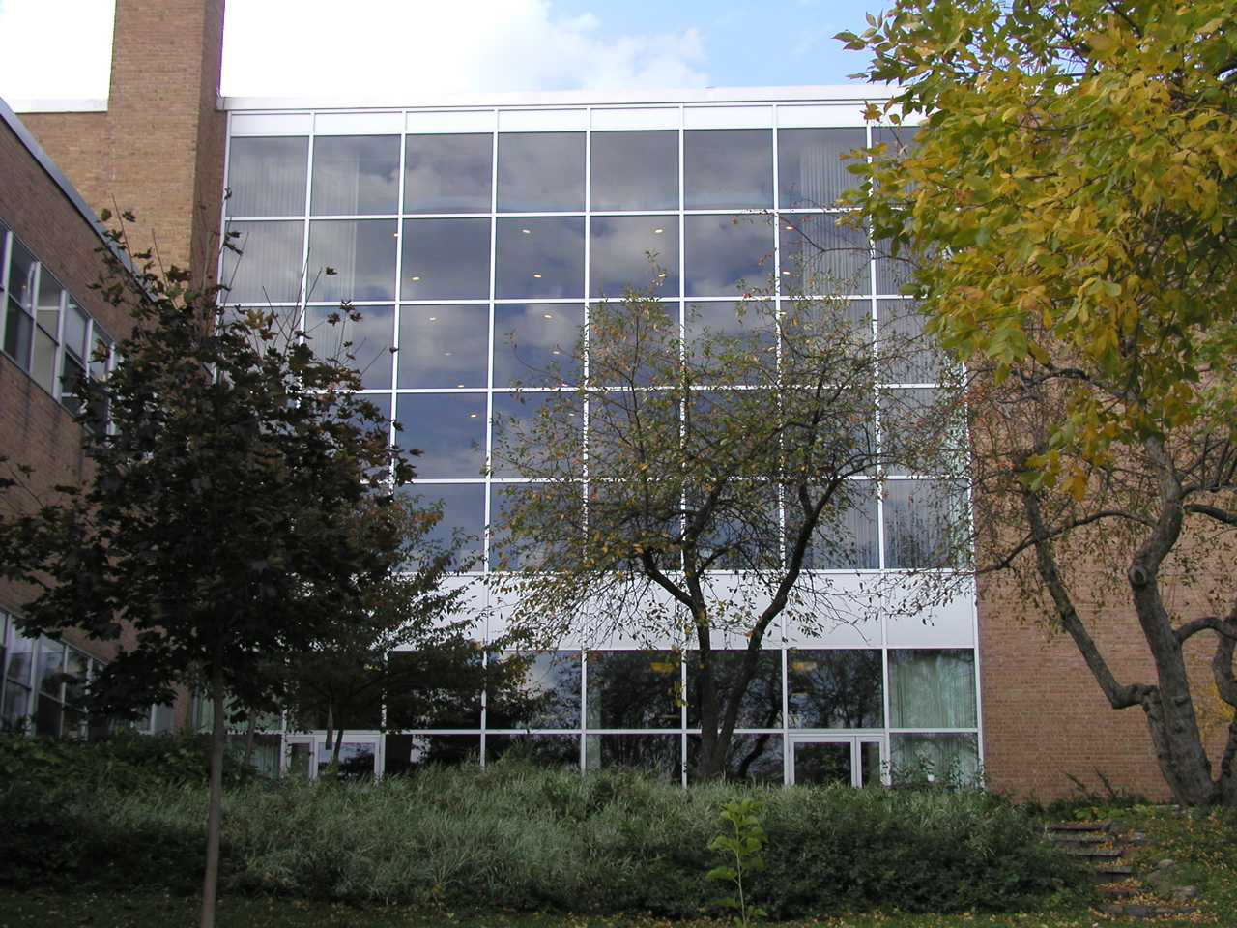 | Welcome to the Twin Cities!  The First Unitarian Society of Minneapolis welcomes you to our community! We hope you will plan to extend your stay by a day or two, to see some of the new and exciting things to do in our beautiful area.
Sunday services will be held at First Unitarian Society of Minneapolis, which has a rich history in our movement.
While you’re in the Twin Cities, you can enjoy:
An Easy Walk to….  - The Hennepin Avenue Theater District, featuring Broadway and other productions in the historic Orpheum and State theaters  - Orchestra Hall, where the Minnesota Orchestra performs under the award-winning baton of Osmo Vanska  - The Block E entertainment complex, with movie theaters, shopping and dining  - Shopping and dining on Nicollet Mall  - The Hiawatha Line light-rail, with service to the Hubert H. Humphrey Metrodome, beautiful Minnehaha Falls Park, historic Fort Snelling, the Minneapolis/St. Paul International Airport, and the Mall of America  A Longer Walk to….  - The new Guthrie Theater on the river, home to Minnesota’s most famous repertory theater company  - The historic Stone Arch Bridge, St. Anthony Falls, and Mill City Museum, symbols of Minneapolis’ mill town history  - The newly renovated Walker Art Center and Minneapolis Sculpture Garden, just next door to First Unitarian Society |  | A Short Drive to….  - Downtown St. Paul, home to the Science Museum of Minnesota, the Minnesota Children’s Museum, the Minnesota History Center, the Ordway Center for Performing Arts (home of the St. Paul Chamber Orchestra) and Minnesota’s beautiful State Capitol Building  - The Minneapolis Lakes District with the beautiful chain of lakes and parks that makes Minneapolis unique  - The Uptown district in Minneapolis, home to coffee shops, independent theater, antiques, and some of Minnesota’s best ethnic dining  - The Minnesota Landscape Arboretum, with more than 1,000 acres of public gardens  - The Minnesota Zoo, home to over 400 different animal species, with miles of indoor and outdoor trails, an aquarium, and monorail  - So many Parks and Lakes, with opportunities for hiking, biking and more, that it would be impossible to list them all!

Prairie Star District
Unitarian Universalist Association
122 W. Franklin Avenue, Suite 303
Minneapolis, MN 55404

(Please send registration to address on form only.)

2007 ANNUAL CONFERENCE
Nurturing Our Faith Communities

Prairie Star District
Annual Conference
Minneapolis Marriott City Center
April 13-15, 2007

